1.Write a Java method to find the smallest number among three numbers.

Test Data:  
Input the first number: 25  
Input the Second number: 37  
Input the third number: 29

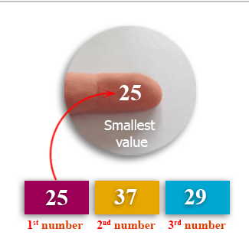

2.Write a Java method to compute the average of three numbers.

Test Data:  
Input the first number: 25  
Input the second number: 45  
Input the third number: 65

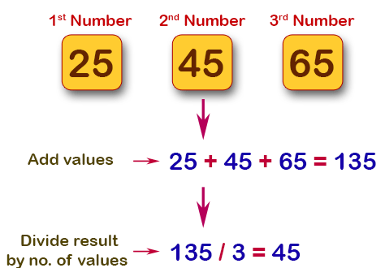

3.Write a Java method to display the middle character of a string.

Note: a) If the length of the string is odd there will be two middle characters.

b) If the length of the string is even there will be one middle character.

Test Data:  
Input a string: 350

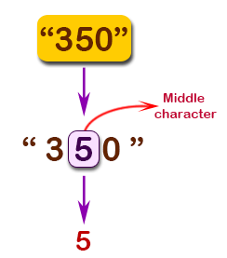

4.Write a Java method to count all words in a string.

Test Data:  
Input the string: The quick brown fox jumps over the lazy dog.

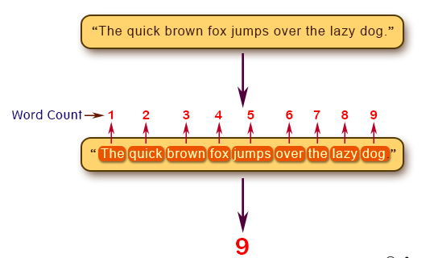

5.Write a Java method to compute the sum of the digits in an integer.

Test Data:  
Input an integer: 25

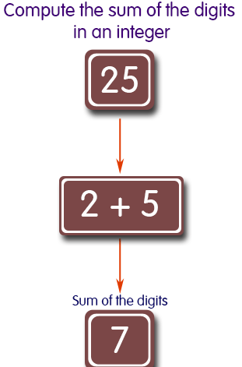

6.Write a Java method to check whether an year (integer) entered by the user is a leap year or not.

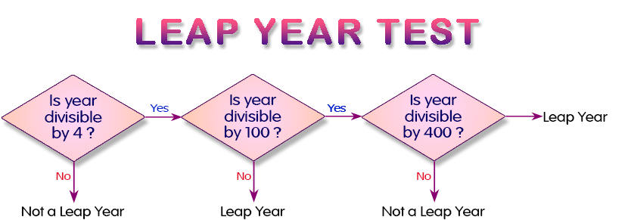

7.Write Java methods to calculate the area of a triangle..

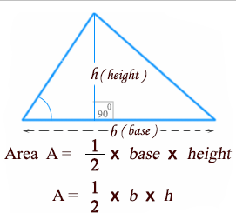

8.Write a Java method to create the area of a pentagon.

